Course/ Subject/Level: | BSc (Hons) Computing & BEng (Hons) Software Engineering  SWE6204- Machine Learning Level: 6
Learning Outcome | After completing this session, you will be able to work towards:  LO2: Identify fundamental, social and ethical issues of applying Machine Learning in designing and implementing real-world applications.  LO3: Reconstruct the state-of-the-art machine learning algorithm to solve a real-world problem.
Topic: | Tutorial: Installation of Tool-Anaconda
Week | 2 | Time Duration: | 10:00 to 5:00

Learning Method: Practical and Peer Review
References:
Anaconda.,2022,Anaconda Documentation. [Online]
Available at: https://docs.anaconda.com/anaconda/navigator/
Anaconda,2022.Individual Edition. [Online]
Available at: https://www.anaconda.com/products/individual
To Practise Examples from: https://www.w3schools.com/python/python_syntax.asp
In the given tutorial, you will walk through various tasks of installation of Anaconda Navigator and launch jupyter notebook for working with Python and data visualisation. Ensure to follow the various stages accordingly as given below.
https://www.anaconda.com/products/individual
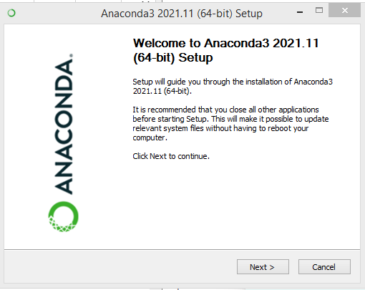

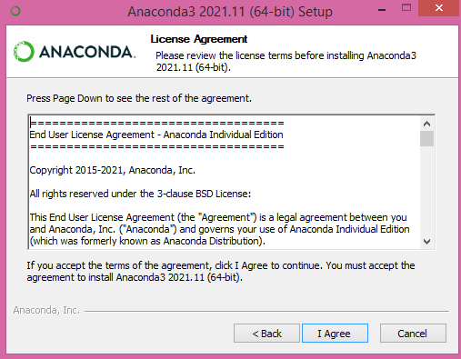

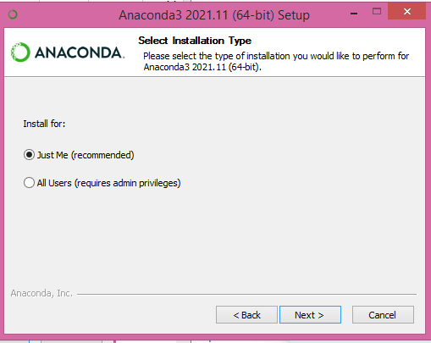

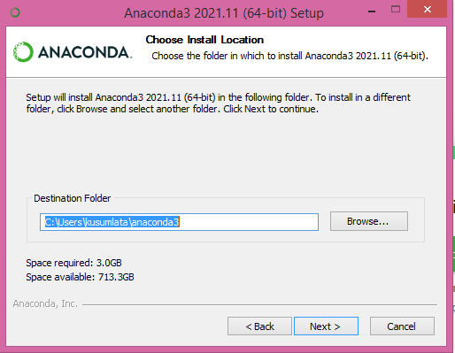

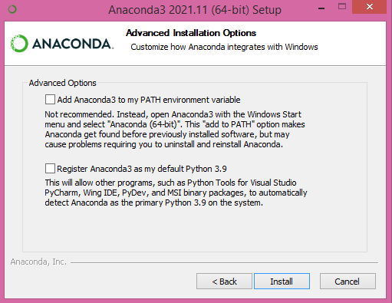

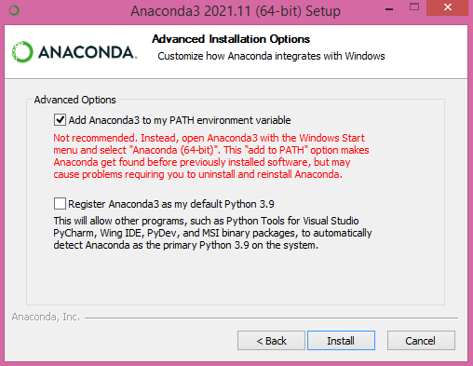

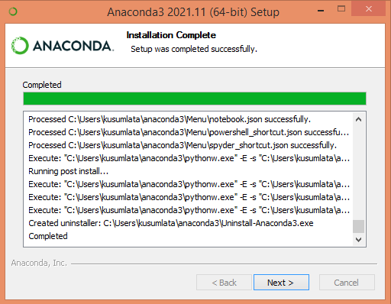

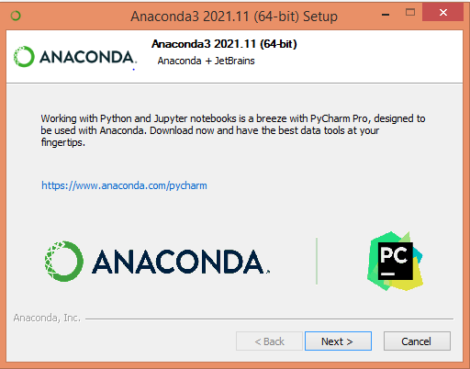

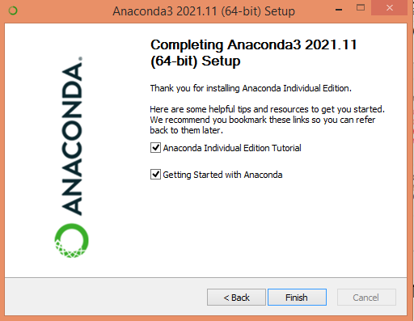

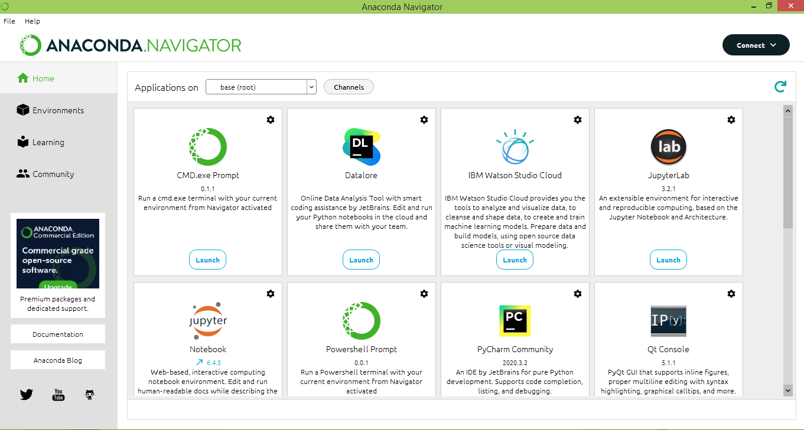

After finishing the installation, launch jupyter notebook for working with Python

Alternative to Jupyter Notebook
What is Google Colab?
- Google Colaboratory (Colab) is a free, cloud-based platform provided by Google for writing and running Python code in a web browser.
- It provides a Jupyter-like interface, so learners familiar with Jupyter will feel comfortable.
- Requires only a Google account – no installation needed.
Why use Google Colab as an alternative to Jupyter Notebook?
- No local setup required – runs in the cloud without needing to install Python or packages on your computer.
- Free access to GPUs/TPUs – ideal for training deep learning models and handling computationally heavy tasks.
- Seamless integration with Google Drive – notebooks can be stored, shared, and collaborated on like Google Docs.
- Pre-installed libraries – common ML/DL libraries (TensorFlow, PyTorch, scikit-learn, pandas, NumPy) are already available.
- Collaboration-friendly – multiple users can work on the same notebook in real-time.
When to use Google Colab instead of Jupyter Notebook?
- For beginners or students – when setting up a local Python environment is difficult.
- When you need extra computing power – access free GPU/TPU resources without expensive hardware. This feature is handy while working with AI/ML algorithms as such algorithms could be computationally expensive.
- For collaboration and sharing – easier to share work with peers or instructors.
- For cloud-based storage – projects are auto-saved in Google Drive, reducing risk of data loss.
- For portability – you can access your notebooks from any device with internet access.

How to use Google Colab?
Watch this YouTube Video to get a full understanding of what is Google Colab and how to use it.

Discussion or any points to share:

